Rotary Club of Berri
Bulletin
Meetings held fortnightly at the Berri Resort Hotel,
Riverview Drive, Berri. Mondays 6.15 for 6.45pm
District 9510 Governor – Paul Thomas AM Area Governor – Bill Simons

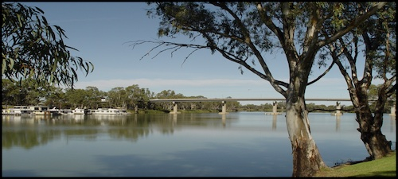
2022 – 2023 Board
President : Peter Jarvis Secretary: Bruce Richardson: Treasurer: Vicky Andriske
Directors : Bruce Richardson OAM, John Rix OAM, Mary Hansen

Last Rotary Meeting

The meeting was not well attended and as there was a quorum of Board members, the Club held its Board meeting to discuss up coming events.

Next Meeting 2791 - 23rd January 2023

Jan 23rd Club Meeting, with a visit from DG Paul Thomas and his Wife Katherine

Future Meetings – (Two each Month)

Feb 10th Riverland and Mallee Vocational Awards Dinner
Feb 27th Club Meeting followed by Board meeting
March 27th Club Meeting followed by Board meeting
April 24th Club Meeting followed by Board meeting

Dates for your Diary
Jan 26th Australia Day BBQ on the Barmera Lake shore, Ampitheatre area. 7am set up, finish 9am

Dates to remember

The Birthday Box

Happy Birthday  Mary Hansen  Tony Smith |  | Happy New Year  2023

Please take note of the roster below – Mark it on your calendar

Club Meeting Roster
Date | Equipment | Plaques
January | January  All members | January  All members | Attendance:  Vicki Andriske | Apologies to:  Bruce Richardson

If you are unable to fill your rostered duties please contact Secretary Bruce

