Rotary Club of Berri
Bulletin
Meetings held fortnightly at the Berri Resort Hotel,
Riverview Drive, Berri. Mondays 6.15 for 6.45pm
District 9510 Governor – Paul Thomas AM Area Governor – Bill Simons

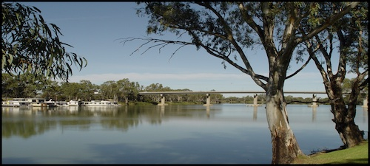
2022 – 2023 Board
President : Peter Jarvis Secretary: Bruce Richardson: Treasurer: Vicky Andriske
Directors : Bruce Richardson OAM, John Rix OAM, Mary Hansen, Kerry Woolston

Last Rotary Meeting

Berri Rotary were happy to receive a visit from DG Paul Thomas and his wife Katherine. I was in awe listening to DG Paul’s experiences through the opportunity to be an exchange student, his close ties with Japan, people he has met there and the continued connection he maintains to this day.

This is a perfect example of the effects that Rotary can have on all people who are given the chance to make life time connections that shape and mould their very lives. Paul also brought greetings and messages from the World President, Jennifer Jones, championing her message to all Rotarians, Equity, Diversity and Inclusion https://www.rotary.org/en/2022-23-president-jennifer-jones-eager-advance-rotarys-narrative

This is a very interesting read for any of you that have not investigated who Jennifer Jones is and what she has been able to achieve so far. Well worth the read.

Katherine championed the Childhood Cancer Foundation. She demonstrated a duffle bag that is available to children up to the age of 18 who are on this unfortunate journey, it contains 3 vouchers, $100 each. A soft toy Dog with the Rotary Emblem on its ear, a compendium, which gives the user the opportunity to record their journey to recovery, Toiletries according to gender. The value of the bag is $50.00, Clubs are encourage to purchase these bags to support the Childhood Cancer Foundation. Bag and Contents are valued over $400.00 Please click on this link for more information. https://www.childrenscancerfoundation.com.au/

The Berri Rotary Club were able to provide their services to the Berri Barmera Community at the Australia Day Celebrations on the Lake Front in Barmera, with, cooking an Egg and Bacon sandwich for all in attendance.+ Special thanks go to: Peter Jarvis, Steve Rundell, Mary Hansen, Vicky Andriske, Bruce Richardson, Kerry Woolston, Kathy Richardson, Pattie Allen and Ian Campbell for their support on the day.
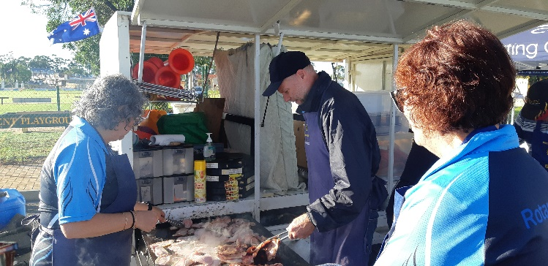
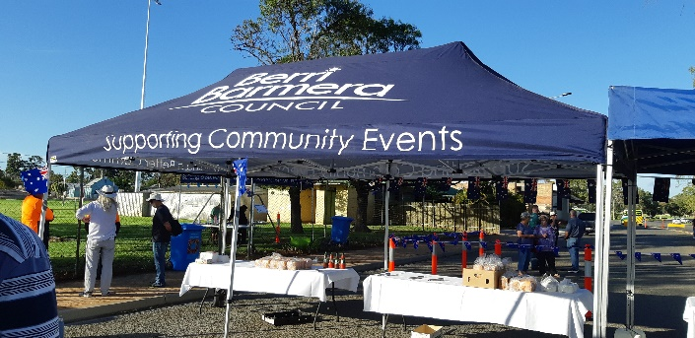
Berri Barmera Council were able to provide shelter for the event with much appreciation from the Rotary Club of Berri
On the Bacon BBQ were Vicki and Steve with Kerry waiting in the wings for supplies to be served to the waiting crowd

.
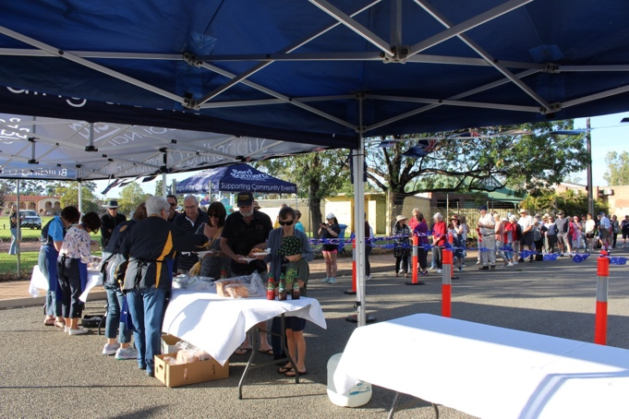

On the other BBQ plate were, President Peter Jarvis and Ian Campbell having a cracking good time with the eggs
Serving were Kerry Woolston, Pattie Allen, and Mary Hansen

Next Meeting 2791 10th February 2023

Feb 10th Riverland and Mallee Vocational Awards

Future Meetings – (Two each Month)
Due to public Holiday, Note the next 3 months of Meeting Dates.
Feb 27th Club Meeting Board Meeting
March 27th Club Meeting Board Meeting
April 24th Club Meeting Board Meeting

Dates for your Diary

Dates to remember

The Birthday Box

Happy Birthday  Mary Hansen  Tony Smith |  | 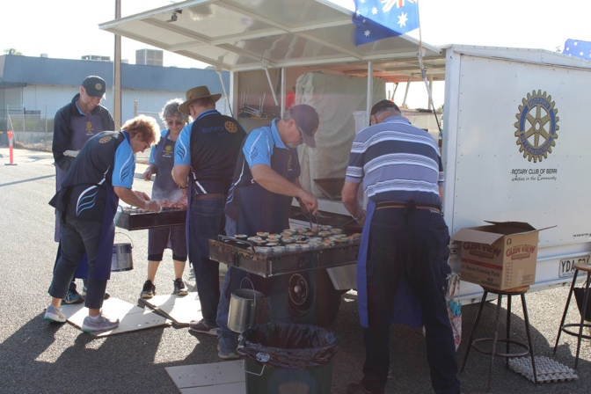

Please take note of the roster below – Mark it on your calendar

Club Meeting Roster
Date | Equipment | Plaques
January | January  All members | January  All members | Attendance:  Vicki Andriske | Apologies to:  Bruce Richardson

If you are unable to fill your rostered duties please contact Secretary Bruce

